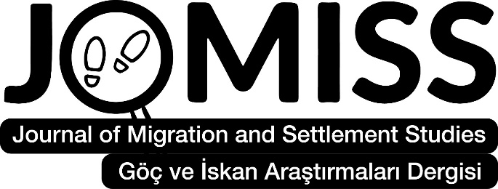
www.jomiss.com.tr
Journal of Migration and Settlement Studies (JOMISS) was established in Türkiye in 2023. It is an open access, international peer-reviewed journal. Scientific studies about migration/settlement written in different disciplines such as History, Literature, Geography, Sociology, Psychology, Anthropology, Archeology, International Relations, Public Administration, Educational Sciences, Law, Music, Theology, Economics, Folklore, Art History, etc., to be published in the journal are accepted.
The journal is published twice a year (June and December) in one volume. Scientific articles sent to the journal for publication should be in Turkish or English. No money is required for publication. In order to submit an article to the journal, a free membership to the journal must be created on the website. Article refereeing processes are done through the system. The publication process of the articles is decided within a maximum of two months.
You can upload your articles to the Journal of Migration and Settlement Studies through the system until May 15 for the June issue and until November 15 for the December issue.
The EDITORAL BOARD of Journal

Prof. Dr. Brema Ely DICKO, Université des Lettres et des Sciences Humaines de Bamako, Mali
Prof. Dr. Emina Berbić KOLAR, J.J.Strossmayer in Osijek, Croatia
Prof. Dr. Qasım HACIYEV, Azerbaycan Milli İlimler Akademisi, Azerbaijan
Prof. Dr. Mahboob Hussain, University of the Punjab, Pakistan
Prof. Dr. Osman GÜMÜŞÇÜ, Çankırı Karatekin University, Türkiye
Prof. Dr. Redžep ŠKRİJELJ, Novi Pazar State University, Serbia
Prof. Dr. Sadhana MANİK, University of KwaZulu-Natal, South Africa
Prof. Dr. Üçler BULDUK, Ankara University, Türkiye
Assoc. Prof. Dr. Baha ÖZTUNÇ, Tokat Gaziosmanpaşa University, Türkiye
Dr. Aigul SADYKOVA, Pavlodar Pedagoji University A. Margulan, Kazakhistan
Dr. Marina ALEIXO, University of Minnesota, United States of America

For more detailed information, please visit the journal page: www.jomiss.com.tr
Prof. Dr. Alpaslan DEMİR
Tokat Gaziosmanpaşa University, Türkiye
Editor of Journal of Migration and Settlement Studies

